Close Out Report: Product Validation

# Automating Enrollment Proofs

**Report Date**: Feb 4, 2025

**Project Team**: [Emily Herrick - Q2AAFDA](mailto:emily.herrick@gsa.gov) [Samantha Noor - Q2CBF](mailto:samantha.noor@gsa.gov) [Jill Foley - Q2AAFDA-C](mailto:jill.foley@gsa.gov) [Robin Kane - QQHC-C](mailto:robin.kane@gsa.gov)

| Executive Summary Anne, a single mother, spends hours gathering and submitting information to prove she qualifies for government services. Each agency asks for the same information, yet no system allows her to share it seamlessly. This research set out to solve that problem: **Can technology streamline enrollment proof verification across government services?**  Between October-December 2024, the PublicBenefits Studio within Technology Transformation Services (TTS) interviewed 20 experts, including policymakers and federal/local public benefits administrators, to explore a federal solution. Initially, we hypothesized that a cross-program enrollment lookup tool leveraging categorical and adjunctive eligibility policy could help agencies verify enrollment. While this approach showed promise for smaller programs, it was not a scalable solution for larger programs already using integrated eligibility and enrollment (IE&E) systems.  Through this research, we learned that the real challenge is not automating proofs but improving data-access frameworks and standardizing data-matching processes. By focusing on these structural barriers, agencies could reduce administrative burdens and streamline access to benefits. Key Opportunities for Federal Action Rather than a standalone tool, our research identified three strategic interventions:   1. **State of State Systems Dashboard** – A central hub to track state modernization efforts and share best practices. (Short term) 2. **Federated Data-Matching tools and Sharing Frameworks** – Secure, decentralized, and standardized mechanisms for agencies to compare and verify data. (Med term) 3. **Automated Verifications via Login.gov and/or 10x Forms Platform** – Expanding Login.gov’s capabilities and leveraging the 10x Forms platform to include eligibility verification. (Long term)   As of December of 2024, the General Services Administration’s (GSA) Technology Transformation Services (TTS) is well positioned to lead these efforts by providing technical assistance, standardized data-matching tools, and policy guidance. |
| --- |

# Introduction: The Problem

Government programs often operate in silos, leading to inefficiencies in verifying eligibility. Many programs have policies allowing [categorical](https://docs.google.com/document/d/1XuDPhkhuvSmIPjDS8OM7zR3QvIThKk4sqW07SsvijFI/edit?tab=t.0#heading=h.afnkv0k94qxl) or [adjunctive](https://docs.google.com/document/d/1XuDPhkhuvSmIPjDS8OM7zR3QvIThKk4sqW07SsvijFI/edit?tab=t.0#heading=h.g56eo4n8hodu) eligibility, but implementation remains manual, inconsistent, and burdensome for caseworkers and beneficiaries alike.

For example, when a person qualifies for SNAP, they are often automatically eligible for the National School Lunch Program (NSLP), but states handle verification differently—some require additional documents while others have automated checks. This inconsistency slows down access to benefits and increases administrative costs.

This research aimed to explore how a federal shared solution could support more efficient cross-program enrollment verification.

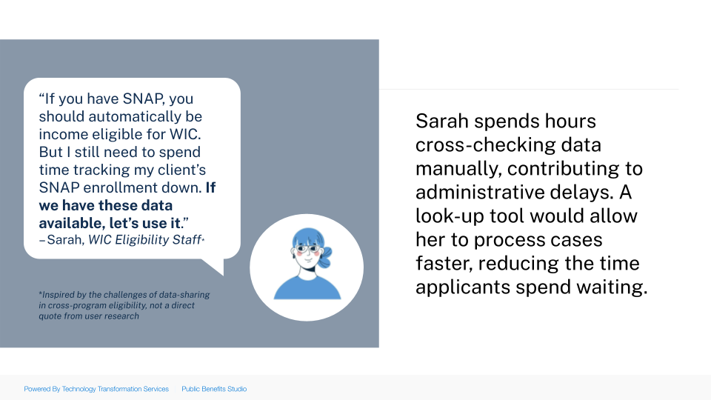

*Visualizing the problem*

# Hypothesis 1: Enrollment Look-Up Tool

We initially hypothesized that a **cross-program enrollment look-up tool** would streamline eligibility verification across major federal programs like Medicaid, WIC, SNAP, and NLSP. The idea was that such a tool could reduce administrative burdens for caseworkers by automating eligibility verification.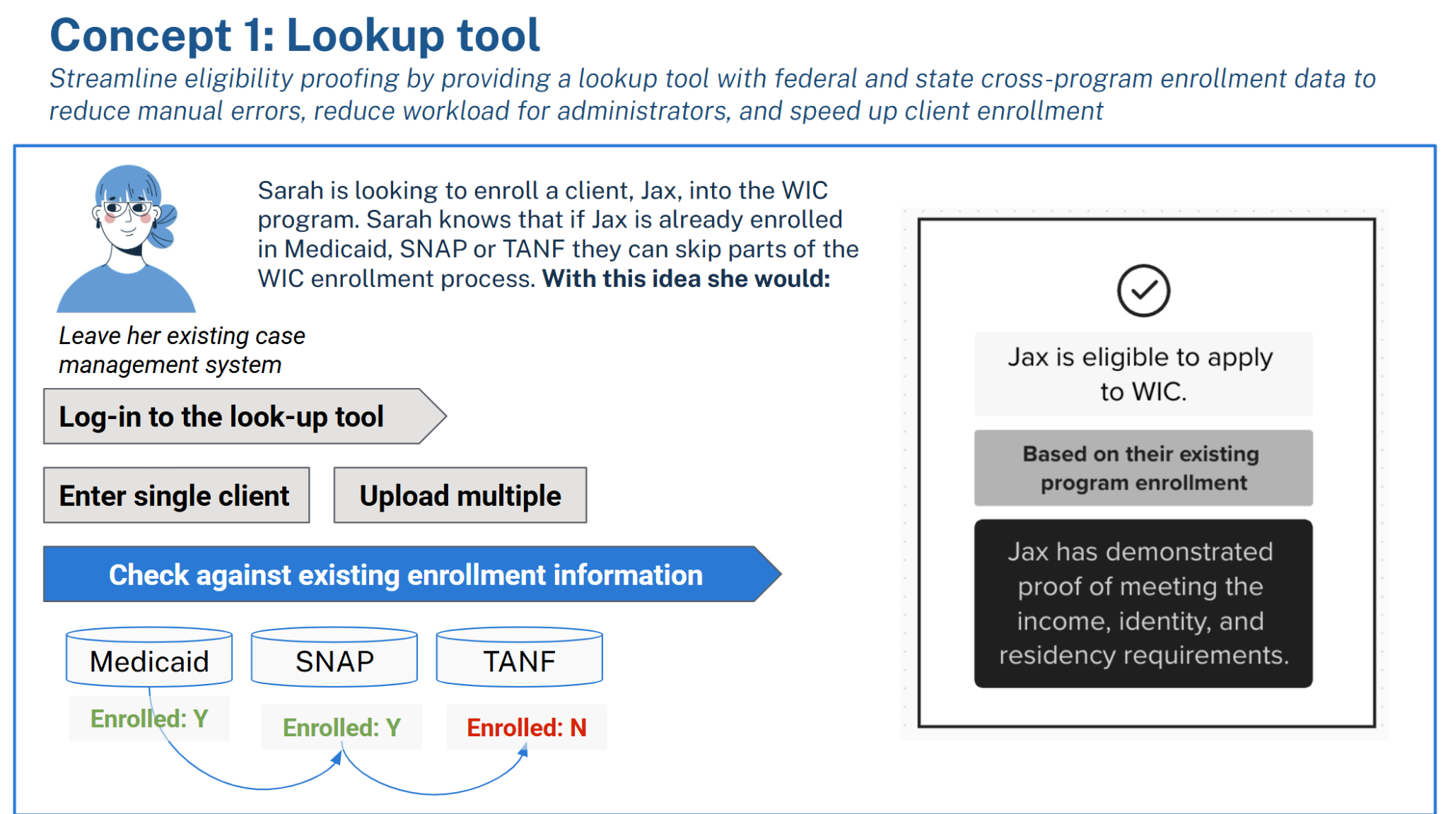

*Concept 1: Enrollment Lookup Tool*

A key grounding force for our original concept is an existing example of a federally-managed eligibility look-up tool: the [National Verifier](https://www.usac.org/lifeline/national-verifier/), which serves two federal programs. An alternative federal shared solution, which could benefit additional government programs, does not exist, signaling a market gap.

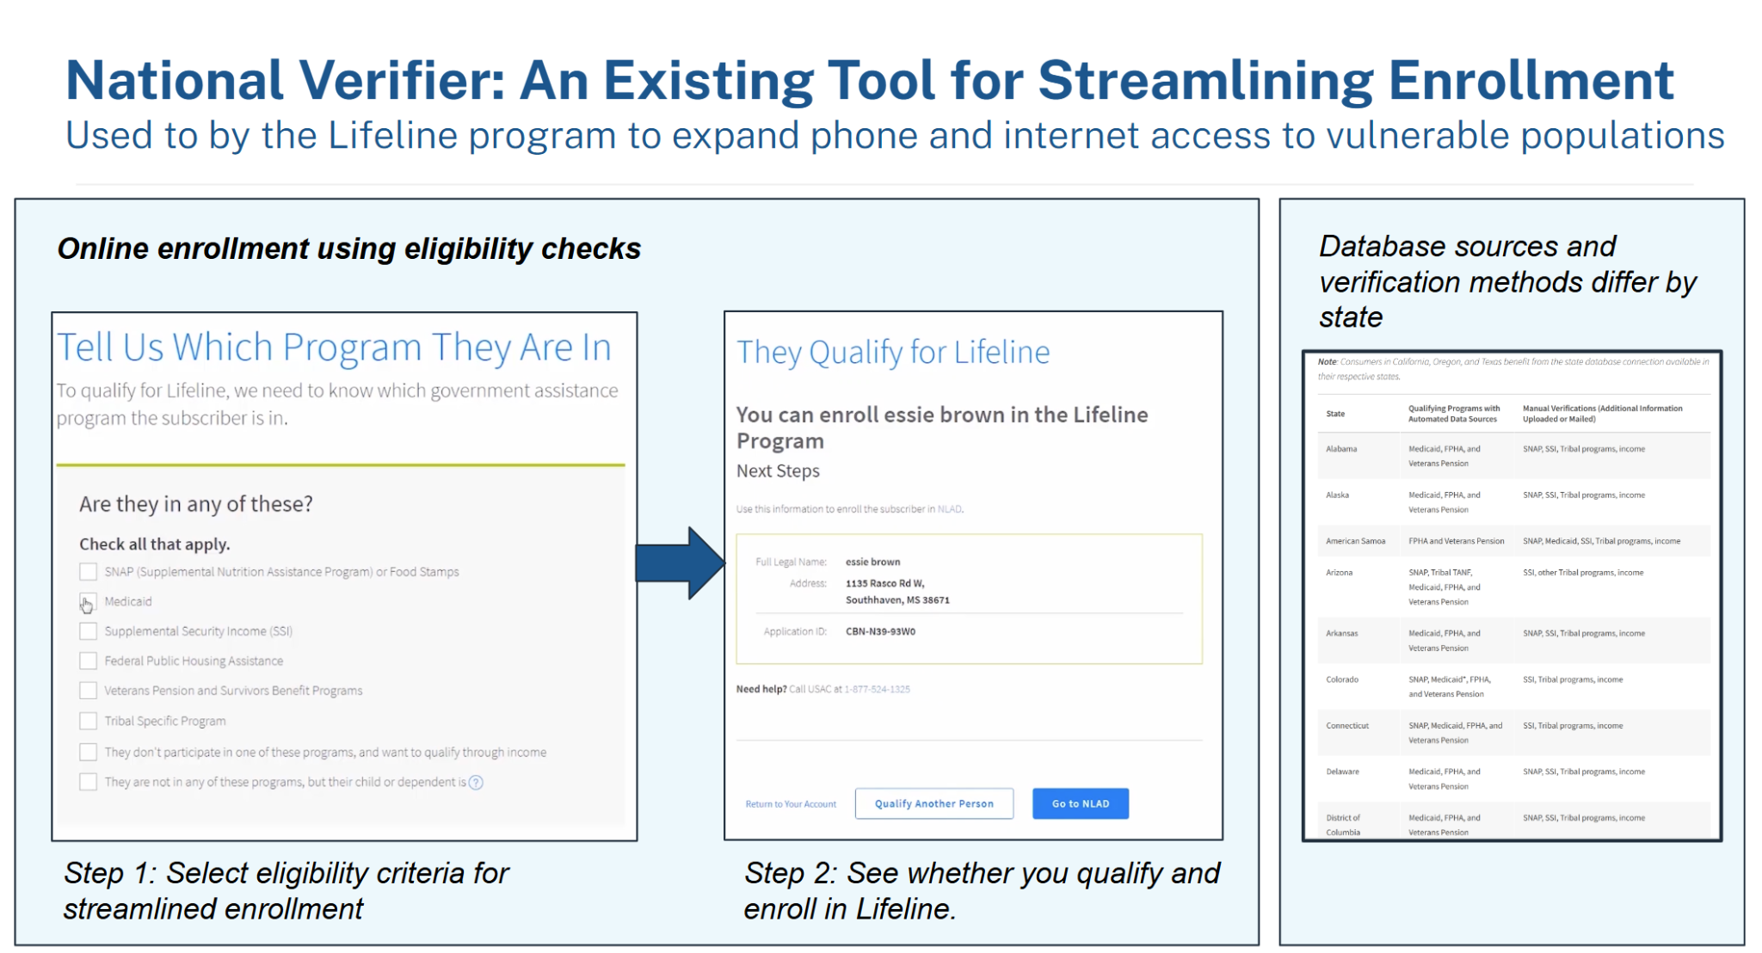

*National Verifier: An Existing Tool for Streamlining Enrollment*

### What We Learned

Our research revealed **key barriers** that would limit the scalability of a new federal enrollment lookup tool.

1. **Most large and medium-sized programs already operate within integrated eligibility and enrollment (IE&E) systems**, reducing the need for a federal standalone lookup tool. [About two-thirds of states](https://aspe.hhs.gov/sites/default/files/private/pdf/255411/StateHHSSystems.pdf) already have these systems, which facilitate multi-program enrollment for major programs like SNAP, Medicaid, and TANF. These systems benefit from federal incentives, such as [Medicaid’s 90/10 Enhanced Federal Funding](https://www.medicaid.gov/federal-policy-guidance/downloads/SMD16004.pdf).
2. **Standalone federal lookup tools face jurisdictional and operational challenges.** While the National Verifier (administered by the Universal Service Administrative Company under the direction of the FCC) is a proven example of a federal enrollment lookup tool, our research suggests that replicating this model for additional government programs that pull from state data would require state-to-federal data-sharing agreements that are unlikely to scale efficiently.  
     
   Many stakeholders expressed skepticism about federal involvement in direct enrollment lookup tools, noting that the federal government lacks jurisdiction in certain areas and that passing data through the federal level is politically, legally, and operationally complex. The federal government is not always seen as a natural owner of an enrollment lookup tool due to existing state-led systems.

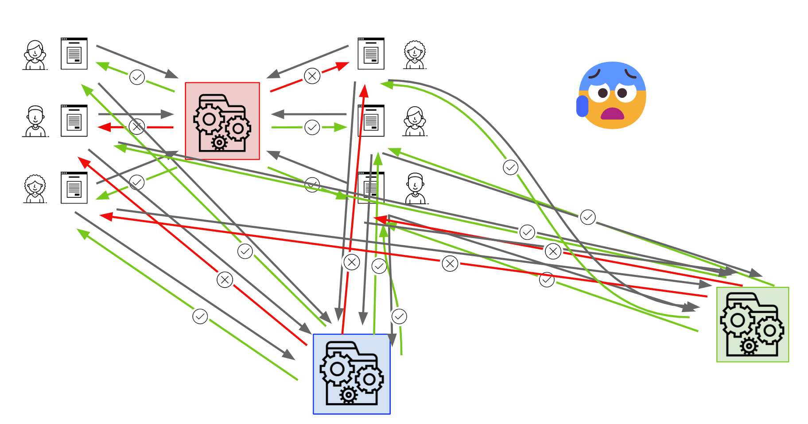

*Source:* [*18F Eligibility APIs Close-Out Presentation:*](https://docs.google.com/presentation/d/1MEoLxVexft_Xx_Auct9M0SBTCYY1gF2QFTbEEQQDfZM/edit#slide=id.g925a65866b_1_302) *The Current State of Eligibility Systems:   
A Complex, Fragmented Web of Siloed Processes*

1. The lookup tool would have to be **comprehensive and compelling enough to supplant whatever agencies are already doing**, such as a system which pulled from multiple (e.g., 3+) large databases.
   * “Do not build on NSLP and WIC as primary use case UNLESS we had 3+ data sources and built into their systems” – Senior Policy Analyst, Center for Budget and Policy Priorities
   * “Given states all have these, would there be an advantage to switch to a new tool? Maybe if you can check Medicaid, SNAP, TANF simultaneously. Certainly, if you can build into MIS systems, but I don’t know about feasibility” – Senior Policy Analyst, Center for Budget and Policy Priorities
   * “There’s a lot of interest… but it hasn’t happened. I think it’s because there are 50 states to integrate with and each state needs different data.” – USDS Designer, Income Verification as a Service (IVaaS)

### Pivot to Smaller Programs

Given these insights, we pivoted to exploring **data-sharing challenges and opportunities for smaller programs** that lack integration into state-level IE&E systems and that could **leverage federal data**. While large programs already have (or are in the process of building) data-sharing infrastructure, many smaller programs – such as transit, LIHEAP (Low Income Home Energy Assistance Program), and CCDF (Child Care and Development Fund) benefits – often operate with manual, inconsistent eligibility verification mechanisms, making them strong candidates for federal support in streamlining data sharing.

Manual verification processes can be time-consuming and resource-intensive for smaller programs. A [report](https://www.gao.gov/products/gao-21-183) by the U.S. Government Accountability Office (GAO) highlights that while electronic data verification can improve efficiency, not all programs mandate its use, leading to inconsistent practices and potential inefficiencies.

The same GAO report found that the use of electronic data sources to verify income and assets varies among programs, which can result in inefficiencies and challenges in accurately determining eligibility.

These programs face unique **challenges,** and our research revealed that there may be **opportunities** for a federal shared solution in this space:

#### Key Findings by Program Area

There is a market gap for smaller programs, especially those with inconsistent eligibility verification methods. Benefits administrators see GSA and TTS as well-positioned to lead an effort on data sharing and technical standardization for these programs. Opportunities exist within the following spaces:

1. **Transit Benefits**

The process of verifying eligibility for transit benefits has long been an **administrative burden** for both transit agencies and beneficiaries. Many transit systems still rely on **check methods** (e.g., visual checks), requiring individuals to present **physical proof of eligibility** or undergo **lengthy approval processes**.

In addition, instances of **misuse**, such as the unauthorized sale of transit passes, can undermine the integrity of reduced fare programs. For example, in New York City, students were found [selling school-issued OMNY cards](https://nypost.com/2024/09/14/us-news/savvy-students-selling-school-issued-omny-cards-online-for-up-to-700/) intended for free rides, highlighting challenges in monitoring and enforcing proper use. In response to these challenges, efforts are underway to explore **automated solutions**.

The **California Integrated Travel Project (CAL-ITP)** as well as [Florida’s Pinellas Suncoast Transit Authority](https://www.transportation.gov/sites/dot.gov/files/2024-12/FY24%20Stage%201%20SMART%20Project%20List.pdf) is addressing this challenge by integrating its reduced fare enrollment system with **Login.gov**. This approach streamlines identity verification, reduces administrative overhead, and prevents fraud by leveraging a trusted federal authentication platform. The initiative demonstrates how federal identity tools can be used to modernize benefit verification processes.

Additionally, the **CAL-ITP** has developed an eligibility verification system that leverages **federal Medicare enrollment data** using [CMS Blue Button 2.0](https://api.bluebutton.cms.gov/). This model allows beneficiaries to **opt into data sharing**, enabling transit agencies to confirm eligibility through an **application programming interface (API)** rather than requiring **manual check** ([Youtube demo](https://www.youtube.com/watch?v=YZylD7oAbso)). The system is designed to be scalable and could extend beyond transit benefits to other public assistance programs such as LIHEAP and childcare subsidies.

This approach has drawn significant interest from agencies looking for more efficient ways to manage their benefit programs. The Director of Fare Technology at the San Diego Metro Transit System expressed enthusiasm for automation, stating, *"If there’s an automated way similar to our [automated] age verification—SSA, SSI, Medicare—yes, we would want to go down that road."*

Parallel to CAL-ITP’s work, the **Rebel Group** has been engaging with federal and state agencies—including the California Department of Technology, 15 transit agencies, and other stakeholders—to shape broader strategies for automating transit benefit verification. Rebel’s team has emphasized the importance of **flexible data-sharing solutions** rather than imposing a **one-size-fits-all model**. The potential for a federal shared solution is particularly compelling. *"There is a lot of interest in a federal product,"* noted a managing director at Rebel Group. *"This model could work across all states, all programs."*

Despite these promising developments, challenges remain. Eligibility verification criteria vary across transit agencies—for example, some provide benefits to riders at age 60 while others require riders to be 65. Additionally, in the CAL-ITP Blue Button 2.0 API use case, not all Medicare enrollees have Medicare.gov accounts, which can create scalability issues for digital verification systems. Additionally, this does not account for when you are no longer eligible for the program (e.g., if you no longer have a disability, but still retain access to your CMS account). However, agencies recognize the need for innovation. *"Thousands of transit authorities are required to, or want to, offer these benefits,"* one contractor observed. *"I think the GSA is well positioned to own this tool."*

The success of **CAL-ITP’s API-based verification model**, coupled with interest from federal agencies in expanding eligibility automation, signals a significant shift in how public benefits could be administered. Additionally, there are strong policy levers in place: regulations put forth by the Federal Transit Authority requires federally subsidized transit providers to offer reduced fares to people with disabilities, seniors, and Medicare cardholders. With federal backing and continued refinement, these tools could dramatically reduce administrative burdens and improve access to essential services for millions of Americans.

*The Federal transit and DOT did have a conversation with Login.gov [in Fall 2024] because agencies are* ***required to offer 50% discounts but don’t have tools to do it****. Login is part of the solution, but eligibility is the missing link - it could be a really nice partnership. Mobility is a nice place to start because you’re talking about bussing–****getting people to work****, and it’s a small benefit [from a government perspective].” - Managing Director, Mobility, Rebel Group*

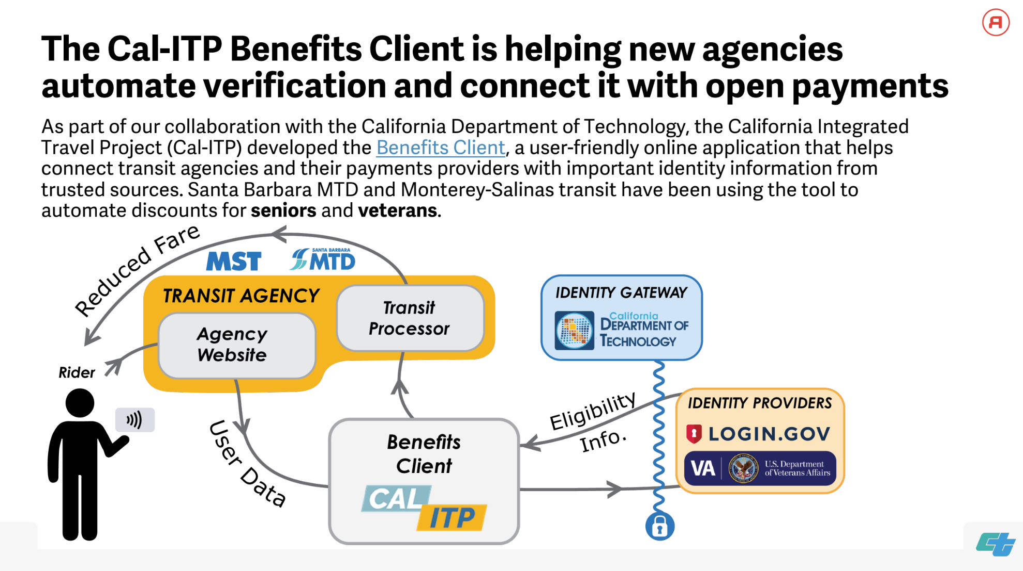

*The CAL-ITP Benefits Client automates fare discounts for seniors by verifying eligibility through Login.gov and Medicare data, streamlining transit agency processes.*

1. **LIHEAP (Low Income Home Energy Assistance Program)**

A federal shared solution to streamline eligibility verification for the LIHEAP and its water assistance counterpart, LIHWAP, could significantly reduce administrative burdens and improve data security. However, several challenges stand in the way, including **state autonomy, complex data-sharing agreements, and the need for integration with existing systems**.

As a block grant program, LIHEAP allows each state, tribal, and territorial administrator to implement its own processes, leading to **wide variations in verification methods**. Some states rely on **manual checks of pay stubs**, others use **tax return data**, and a few are able to integrate with **human services agencies that already have access to eligibility data**. These inconsistencies lead to delays in benefit distribution, which can be particularly harmful during peak energy demand seasons. One director noted that every state does things differently, and there’s no clear federal guidance on what data sources they should be using. They waste so much time verifying income when a shared federal system could solve this.

State program administrators widely agree that streamlining eligibility verification is necessary, but they also highlight jurisdictional constraints and a lack of technical assistance in standardizing data sources. The absence of centralized federal guidance has left many states piecing together data from disparate sources, creating inefficiencies. A LIHEAP program director noted that they would love to see a federal framework for income verification. Right now, they’re cobbling together data from multiple sources, and it’s a mess.

One of the biggest barriers to efficiency is the **burdensome process of securing data-sharing agreements**. These agreements can be 150-200 pages long, limiting access to eligibility data even when states want to streamline verification. While some states **rely on third-party providers like Equifax and Experian**, the cost can be prohibitive, and these providers face skepticism and distrust from beneficiaries and government agencies. As one contractor put it, “The security and safety knowing this is a federal solution from the GSA is not to be underestimated.” Others face federal restrictions, such as limited access to Social Security Administration (SSA) data, making it difficult to verify eligibility efficiently. Security concerns also play a role—Rhode Island, for example, suffered a **major data breach** when using a third-party provider, raising concerns about outsourcing eligibility verification.

For smaller programs like LIHEAP, the federal data lookup tool concept seemed like a promising solution that LIHEAP caseworkers could use to quickly verify eligibility. The idea has strong support among administrators: *“If there can be a federal tool, that would be just brilliant, and we would definitely want to tap into that,”* said the Director of the Division of Energy Assistance (DEA) at ACF. While states would not be required to use such a tool, having the option would expedite verification and reduce the need for manual checks.

Many states also lack the expertise and resources to navigate complex data-sharing agreements on their own. Administrators frequently express frustration over their inability to access necessary information, with one stating bluntly, *“I don’t even know where to start.”*

Beyond technological solutions, **policy changes** are also necessary to facilitate better inter-agency coordination. In Washington, D.C., for example, the Solar for All program sought to integrate LIHEAP enrollment data but was blocked by federal-level restrictions. As one administrator put it, *“Fed level barriers inhibit local conversations.”* Adjusting federal policies to allow for greater collaboration between benefit programs could help more eligible households receive assistance without unnecessary delays.

Finally, many states struggle with **the cost of storing application documents**, which adds an additional administrative burden. A **federal platform for secure data storage** could help alleviate these costs while ensuring caseworkers maintain access to critical applicant information.

1. **Other ACF-Administered Programs**

The Administration for Children and Families (ACF) oversees a range of childcare assistance programs, yet the lack of a **unified approach to data sharing** continues to pose significant barriers to **enrollment verification**. This fragmented landscape creates **burdens for caseworkers** and **hurdles for beneficiaries**, making it difficult to efficiently determine eligibility across multiple programs.

ACF program administrators were particularly enthusiastic about the potential for a federal tool to streamline eligibility verification. While states manage their own childcare assistance databases, many administrators noted that they lack the technical infrastructure to efficiently verify eligibility across programs.

One of the key insights from the ACF discussions was the need for **cross-program eligibility tools** that would allow administrators to quickly and accurately determine whether an applicant qualifies for multiple programs based on existing enrollment records. As one official put it, *"If you can say ‘if you have this information, you qualify for this program,’ that would be a win.”* This type of adjunctive eligibility verification—where participation in one program can confirm eligibility for another—has long been a goal, but existing systems remain disjointed and inconsistent across states.

The discussion also highlighted the work of organizations such as **3SI** (a commercial tool by [dataladder.com](http://dataladder.com)), which has been developing data models to facilitate eligibility verification across **ten states**. Its website states that one program *“obtained a 24% higher match rate using dataladder versus our standard vendor.”*

Ultimately, ACF interviewees emphasized that streamlined data sharing could unlock cross-program enrollment efficiencies, reducing the checks workload for caseworkers and ensuring quicker access to benefits for families in need. *“Having multiple avenues would be huge,”* an official noted, highlighting the necessity of flexible, scalable solutions. With growing interest in federal leadership in this space, ACF programs could serve as a testing ground for broader eligibility verification innovations across government benefits.

#### Cross-Program Takeaways

Across transit benefits, LIHEAP, and other ACF-administered programs, a common theme emerged: eligibility verification is inconsistent, manual, and often inefficient. These programs vary significantly across jurisdictions, making a one-size-fits-all federal shared solution impractical. Instead, stakeholders emphasized the need for flexible, scalable data-sharing frameworks that respect state autonomy while reducing administrative burdens. And, there is a strong desire for transparency and visibility into the initiatives, tools, and processes other states are using as they navigate data sharing challenges.

Opt-in models for data sharing, such as APIs leveraging SSA, IRS, and Medicare data (e.g., CAL-ITP for transit benefits), could provide scalable solutions for transit, LIHEAP, and ACF programs.

### The Bottom Line

Our research efforts confirmed the demand for eligibility data for smaller programs, and we recognized that data sharing, rather than a look-up tool, was the core issue.

# Pathways Forward

Cross-enrollment issues are fundamentally data sharing and data matching issues. A singular stand-alone product is likely not the near term solution, but what is needed, rather, is a systems-level approach that helps government agencies enact more secure-automated sharing and verification of existing administrative data within the contexts it currently operates.

Our paths forward move away from case worker-focused interventions points and towards more upstream levers and have been grounded by insights and opportunities that emerged from desk research and conversations with landscape experts.

## Pathway 1: Federated Data-Matching Tools and Sharing Frameworks

The greatest leverage point to create efficiency within the enrollment process is improving how administering agencies share and match data within the specific contexts they operate.

Across the interviews we heard similar sentiment to this: “For workers, both solutions [data matching and data sharing] should reduce the burden of requesting and processing documentation from applicants. It can also allow workers to expedite an in-person or telephone interview by checking program participation on the spot and eliminating income interview questions when there’s a positive match. [Data matching] would produce a more reliable match, keep the worker in their MIS, and auto-populate the required field(s) indicating adjunctive eligibility.” – USDS Designer

By leveraging proven models and federally supported data-sharing frameworks, states could reduce inefficiencies, minimize administrative burden, and ensure more families receive the assistance they qualify for.

Despite the enthusiasm for a federal shared solution, any intervention must align with existing state-managed databases and respect state autonomy. A federated approach—one that provides standardized technical support and interoperability guidance rather than a one-size-fits-all tool—emerged as the most promising path forward.

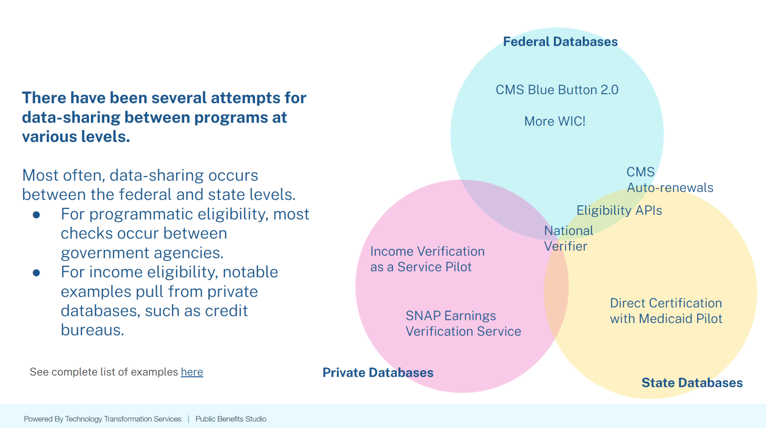

*Data-sharing efforts across federal, state, and private databases   
aim to streamline eligibility verification for public programs*

With these leverage points in mind, there are three data automation opportunity areas ripe for TTS intervention:

### 1 - Data matching products

We heard from numerous experts that data matching technologies are an underexplored area for federal intervention. For example, a cross-enrollment policy expert mentioned “What is underexplored is the matching itself; especially for programs that don't use SSN. WIC is an opportunity for data matching (they don't require SSN).”

Another technical expert with experience helping administrative agencies match Medicaid data with NSLP to expedite enrollment mentioned, “What could be useful is selling states an algorithm that accurately matches people, such as a fuzzy algorithm.”

State agencies all have different approaches to data matching, leading to fragmentation, and inefficiencies. By building out a federal shared service that allows agencies to clean and match disparate data sets using enhanced algorithms and other data matching technologies could provide episodic value to using agencies while also accelerating data matching standards and best practices.

Non-governmental organizations that are already helping states do data sharing also agreed that there is federal opportunity in this space. For example: “As far as [our organization], if there was a federal tech option we could point states to, that would be great. We are always worried about remaining impartial and trying to ensure we are not directing states to one vendor over another. We wouldn’t have to worry about that if there was a federal tech option.” – Data sharing lawyer

In interviews, we learned that some states already use private-sector data matching tools (e.g., Data Ladder) and [conducted a round of desktop research](https://docs.google.com/document/d/1XVcr-hxI0WKBsAI2aksJmKH5ANObQnxuo-WvCB5ZctM/edit?tab=t.0) to identify potential pathways forward.

### 2- Technical frameworks for data sharing

Data sharing is the foundation for data matching. Without a secure, standardized way to share data, efforts to match individuals across programs are inconsistent and inefficient.

Federally-supported data-sharing frameworks can include technical solutions (e.g., APIs, open-source matching tools, interoperability guidance) while also addressing legal and policy barriers to enrollment verification.

Specifically, **API-based data sharing**, similar to **CMS’s Blue Button API**, which allows users to opt in to sharing their Medicare data securely. A similar system for LIHEAP could enable applicants to grant permission for caseworkers to verify their eligibility without requiring extensive document submission. The idea was met with enthusiasm.

**A consent-based federal data-sharing framework** could allow eligibility workers in programs like transit and LIHEAP to access federally maintained data—such as records from the IRS, SSA, or other existing benefit programs like SNAP, SSI, and TANF. This would alleviate administrative burdens, reduce processing delays, and improve efficiency while ensuring states maintain autonomy over their own programs.

### 3- T**echnical assistance:** From g**uidebooks** to wrap-around consulting

With strong structural and cultural disincentives preventing states from openly sharing data across agencies, the demand for data sharing support was clear. But state and federal systems are fragmented, complex, and bespoke.

Helping agencies address their data sharing challenges would be a highly consultative process, requiring legal, technical, and policy expertise.

A federal initiative that provides technical assistance, standardized agreements, including data sharing and computer matching agreements, and community of practice models to share knowledge and build capacity could help states streamline verification efforts without navigating these challenges alone.

### A way forward: Tell Us Once time bound exploration

Out of the three opportunity areas summarized above, data matching products seem to be the most straightforward pathway to continue exploring. We only touched upon this area in this first round of validation research.

We recommend moving forward towards scoping out a time-bound effort as part of the 10x Tell Us Once concept area to better validate if there is a product opportunity for TTS within the data matching space particularly for programs who are trying to match data across programs to increase efficiency in the enrollment process. For example:

* Examine existing federal data-sharing models (e.g., Blue Button API, FEMA-SBA, ACF PARIS data-sharing) to develop best practices.
* Conduct deeper research into how state agencies handle benefits eligibility data-sharing and matching.
* Investigate technical standards for data-matching algorithms, including open-source solutions states could use.

## Pathway 2: State of State Systems Dashboard

The cost of an agency automating data for the first time is large. Administrators are often blocked by the ambiguity that comes with the myriad of new processes and practices that must be implemented when data sharing for the first time.

We heard from both state and federal administrators that there is opportunity to learn from pathways other jurisdictions have taken and that a consolidated view of state agencies' journeys towards modernization might help reduce cost of data automation implementation by gathering and standardizing the tools, approaches, and best practices that are needed for this work.

For example, a State Program Policy director mentioned: “Even documenting who is working on what, so states know. Even repository to share templates, steps, code, that public dollars are recreated, it would save state leaders so much time”. A Federal Program Policy Director echoed similar sentiments: “[If we could see] ways people have done data matching, you would save states years in figuring out what is possible”.

**What is it?** A custom AI-powered data aggregation and visualization tool showing where each state is in its integration/technology efforts so that states can learn from each other and even leverage tools/codebases from each other.

This dashboard could be built by scraping public data sets to parse contract details, as much of this data is already published across disparate parts of the web:

* Data from federal award management systems (e.g. SAM.gov, FAC.gov)
* Data from state project updates and federal agency waiver requests (e.g. USDA’s [SNAP State waiver database](https://www.fns.usda.gov/snap/waivers/rules))
* Data from sources like Code for America, Beeck, etc.

### A way forward: Tell Us Once time bound scoping effort

We recommend scoping a time-bound exploration that could live within the Tell Us Once practice area focusing on surfacing the key user needs and starting data sources while sketching out a path towards a “state of systems” dashboard MVP.

This exploration can build off of mapping work that was started within this validation phase. Our [Benefits Technology within the Enrollment Journey framework](https://www.figma.com/board/gyLHEjqZY5OeuVu8AXS3AF/Benefits-Technology-interventions---INTERNAL?node-id=63-345&t=GvViUERuvqbJKoER-4) can be used as a starting point for developing the technology concepts and parameters that would be mapped within this dashboard.

## Pathway 3: Automated verifications

Across landscape interviews, a place that is ripe for GSA to focus on is expediting how government agencies can better verify frequently requested client-identifying data across existing sources. This reduces errors that potentially come with manual checks and increases efficiency by reducing the repeatedly processing information that is the same across programs. The sentiment that was expressed in a number of interviews: “Why are we paying private sources to access data that is already within the government?”

There was expressed desire from stakeholders that GSA play a large role in negotiating data sharing with large federal agencies, like SSA and IRS, who own vast amounts of client-identifying data that could be better leveraged across government via automated verification processes.

**Further investigations of the possibilities related to verifying income**

Across interviews, we heard that income data both takes longer to verify than enrollment data and is largely more valuable data to have access to. The focus of enrollment proofing data that originally grounded this work was seen as less burdensome than income proof. For example, we heard from a Senior Policy Analyst, Center for Budget and Policy Priorities that “[eligibility checks] are not something caseworkers talk about being difficult. The eligibility determination is a very small piece of the appointments, it's 5-7 mins of a 30-60 minute appointment.”

Alternatively, respondents mentioned that income data is a place ripe for intervention. For example a benefits administrator shared that "self-employment income is the hardest to verify. If we had an AI tool that could pull out relevant information, that would be a game changer."

There have been attempts by both TTS and the United States Digital Service (USDS) to explore Income-Verification-As-A-Service, with USDS running a number of [pilots to validate proof of this concept](https://docs.google.com/document/d/1Cuq4Q1s210hNeLLWlruSueopl2ElykI8/edit) from 2023-2025. In 2022, 18F explored [income verification as a service specifically for SNAP](https://drive.google.com/file/d/118d1i__pX7OsWJsg54zyAJR-anGjVcvI/view) and recommended not building a new shared service for earned income verification.

In the shorter term, the Studio/10x Accelerator will be using income documentation to explore how TTS might use OCR and AI to transform paper-based income documents into machine readable formats via our [document submission work](https://github.com/GSA-TTS/document-extractor-poc/wiki/Introduction:-Better-Document-Submission). These explorations could better define the viability of exploring a wider service around income verification.

### A way forward: Support Login.gov in expanding enrollment proof as identity proof

We recommend that any work exploring the viability of automated verification offered by TTS be in partnership with Login.gov.

Login.gov is already playing a pivotal role in streaming identity verification for government programs. For example, they have partnered with the DOL to do identity verification for unemployment insurance in a number of states. Login.gov has also been used with transit agencies in Florida and California to streamline eligibility verification.

There is increasing opportunity for TTS to expand verification-as-a-service beyond the identity authentication that is being currently done by Login.gov.

Two places to start:

1. **Explore opportunity to pilot a digital proof-sharing API in collaboration with Login.gov and smaller benefit programs like transit benefits, LIHEAP, and childcare subsidies.**
2. **Support Login.gov in expanding their digital proofing authentication to include SNAP and SSA cards.**We heard directly from Login.gov, that currently document verification is only available for State IDs (via two vendors) and newly added passports (via an API with the State Department).  
     
   On the horizon is potential NIST policy change that may require Login.gov to include options for trusted referees to make risk-based decisions about someone’s identity using proof outside of passports and state IDs, for example: SNAP and SSA cards.  
     
   There may be an opportunity for the Accelerators division to partner with Login.gov to help expand their proofing options, while exploring the viability of verification-as-a-service space.

# Appendixes

## Appendix: Data automation paths for service enrollment

Enrollment into a government service largely involves collecting client-identifying data in three categories:

| Frequently Requested Client-Identifying Data | | | |
| --- | --- | --- | --- |
| **Category** | **Identity** | **Existing status-designation and/or program enrollment** | **Income** |
| Question | Who are you/your household (to the government)? | Are you eligible based on who you are to the government?  Are you eligible based on existing enrollment? | For means-tested programs, are your financial circumstances in line with the policy? |
| Answer(s)  (data) | * Name * Age/DOB * Address * SSN * Status:   + Disability   + Veteran   + Marriage   + Death   + etc. | Y/N | Total income =  (earned/given) + assets − expenses |
| Authentication | Valid form of identification (Drivers licences / State ID, passport, SSN) | Often a “visual check” of status-proving documentation (e.g. SNAP card, marriage certificate) | Validated against sources direct from employers and/or third-party data bases (via service called [The Work Number](https://theworknumber.com/)) |

These questions are asked countless times while a member of the public applies for multiple government services. It is well known that there is value in having these data shared across government agency and service but in order to make data interoperable, thus reducing the administrative burden of enrolling the same person into various programs or services, administrating agencies must:

|  | **Data Sharing** | **Data Matching** | **Data Access** |
| --- | --- | --- | --- |
| Steps | **Agree on what can be shared** | **Access data in question, Clean and match available and allowable data** | **Utilize matched and cleaned data across program or agency** |
| Needs | * Align on consent * Align on which data sources and elements * Align on accepted uses * Negotiating expertise and capital | * Technology to assist with ‘fuzzy matching’, standardization, and de-duplication * Standards and open-source starting points to lower barriers /raise the floor of getting started. | * Unified “sources of truth” * Verification services * Privacy-preserving sharing mechanisms (APIs) * Client-centered consent models |
| Existing Concepts | * Technical assistance and playbooks * OPM’s Chief Data Officer COP | * Fuzzy-matching algorithms * Look-up tools (WIC) * PARIS (cross-state data base) | * Master person indexes * Solid Open Source API |

## Appendix: Research overview and highlights

| **Phase 2 User Research Interviewees** | |
| --- | --- |
| **Agency / Organization** | **Title / Role** |
| United States Digital Service | * Engineer, Medicaid unwinding * Designer, Income Verification as a Service (IVaaS) * Designer, Income Verification as a Service (IVaaS) * Designer, Internal Revenue Service * Designer, SNAP Rapid Response |
| Wilmington Public Schools, Massachusetts | * Food Services Director |
| Centers for Medicaid and Medicare Services | * Product Manager, Blue Button 2.0 API |
| Nava | * Consultant, Blue Button 2.0 API * Director, NAVA Labs * Partnerships and Co-lead, NAVA labs * Senior Product Manager, NAVA labs, Artificial Intelligence |
| Rebel Group | * Managing Director, Payments, Mobility, and Insights * Team member, Payments, Mobility, and Insights |
| Johns Hopkins University | * Research Associate |
| San Diego Metro Transit System | * Director of Fare Technology * Director of Support Services |
| Center for Budget and Policy Priorities | * Senior Policy Analyst, Food Assistance |
| Administration for Children and Families | * Director, Division of Energy Assistance (DEA) * Director of Policy and Strategy, Early Childhood Development |
| TTS 10x | * Design Strategist, Tell us Once |
| 18F | * Software Engineer |
| Beeck Center for Social Impact + Innovation | * Program Lead, Network Collaboration |
| Illinois Department of Healthcare and Family Services | * Deputy Director of Strategic Planning |
| United States Digital Response | * Governments Team Lead * Program Director |
| New America, New Practice Lab | * Director of Product * Policy director * Design lead |
| Code for America | * Associate Policy Director * Director of Food Assistance * Program Director, Government Innovation * Product Manager * Program Manager |
| Washington State Department of Social and Health Services | * Product Manager, Integrated Eligibility & Enrollment Modernization Program * Senior Engineering Manager |

### 